**Mechanical Royalties:** Royalties earned through the reproduction of copyrighted works in digital and physical formats. Songwriters are paid mechanical royalties per song sold, downloaded, and streamed via "on-demand" streaming services.

**Master (sound recording) vs publishing rights**:

Master rights refer to the sound recording of the song. These rights are held by the party or entity that financed and produced the recording. In most cases, the master rights are owned by the record label or the artist if they are independent and have retained ownership of their recordings. Master rights are usually time-limited, meaning that after a certain period, the artist may gain the rights to their recordings back (commonly referred to as "reversion clauses").

Publishing rights refer to the actual music composition ( e.g., the notes, melodies, lyrics, etc.). Whoever owns the publishing rights receives royalties whenever the song is played and when the composition is reproduced. These rights are usually owned by the songwriter, composer, or a music publishing company to whom the rights have been assigned or licensed.

**Mechanical royalties are paid to the owners of the publishing rights for the reproduction and distribution of the musical composition itself (the lyrics and musical score).**

## Industry Reports

### “Year-End 2022: RIAA Revenue Statistics”

Streaming accounted for a large majority of recorded music revenues ⇒ record high $13.3 billion in revenue, 84% of total revenues from different formats (cds, vinyl, downloads, etc), grew by 7.3% from 2021

Revenues from paid subscription services grew 8% to $10.2 billion in 2022

Average number of subscriptions for the year grew 10% to 92.0 million

Music revenues from advertising supported on-demand services (such as YouTube, the ad-supported version of Spotify, Facebook, and others) grew at a slower pace than previous recent years, up 6% to **$1.8 billion**

Total physical revenues of $1.7 billion were up 4% versus the prior year

### ifpi: “Global Music Report 2023”

67.0% overall streaming share of global revenue ⇒ 18.7% ad-supported streams, 48.3% subscription audio streams ⇒ streaming dominates the global revenue mix

10.3% growth in subscription audio stream revenue

Rising to US$26.2 billion, the global recorded music market grew by 9.0% in 2022

Performance rights (use of recorded music by broadcasters and public venues grew by 8.6% ⇒ reaching 2.5 billion, but not part of mechanical royalties

Synch rights experience 22.3% growth, accounting for 2.4% of global market in 2022

By service

11.5% growth in overall **streaming** revenues, 589m users of paid subscription accounts ⇒ reaching 17.5 billion USD, though slower growth than 2021 to 2022

4.0% growth in **physical** copies, accounting for 17.5% of revenues overall

-11.7% downloads and other digital ⇒ representing 3.6% of the market ⇒ only format to experience decline, with revenues falling by 19.6%

By region

Maintaining its foothold as the world’s largest region for recorded music, revenues in the **USA and Canada** increased by 5.0% in 2022 ⇒ Maintaining its foothold as the world’s largest region for recorded music, revenues in the USA and Canada increased by 5.0% in 2022, representing 41.6% of global markets

Revenues in **Latin America** rose by 25.9% continuing a decade-plus trajectory of growth

The world’s second largest region for recorded music revenues saw growth of 7.5% in 2022. UK, Germany and France remained the three largest markets in **Europe**, all posting growth (+5.4%, +2.2% and +7.7% respectively

**Other continents** all saw increases in global market share, with streamed music dominating in Middle East and North Africa and possibly all other continents

### Musonomics: “How streaming Has Impacted the Value of Music”

**Key Findings:**

* Streaming contributed 61.5% to the value of music transactions in 2021 ⇒ calculated though impact on rise in NPS (net publisher shares) multiples paid for music catalogues in recent transactions
  + NPS is defined as the amount of royalties received by a music publisher less the amount of the royalties that have to be paid to writers, performers and others who participate in a share of the royalties earned
* Revenue streams from streaming music generates increased investment activity around music royalties and catalogues, as well as record labels exploring public markets
* Streaming helps with resilience, eg during covid streaming revenues grew ⇒ **stability**
* Streaming reduces revenue decay curve ⇒ songs earn money more consistently during their lifespan
* Increased longevity of catalogue music ⇒ top 5.2% of the 500 best-performing albums released in 2018 performed better in their second 18 months following initial release than they did the first 18 months
* Streaming services face many cost pressures from the cost of licensing the music streamed ⇒ they compete on quality of user experience
* Rise in music catalogues as mainstream investment asset class

Investing in music royalties has become a multi-billion dollar business, equally pursued by both multinational investment funds and individual retail investors alike

On the publishing side, U.S. revenues have increased an average of 15.1% a year since 2015 to over $4.7 billion reported for 2021, according to the NMPA ⇒ Performance royalties contributed over 51% of that total, and **mechanical royalties** over 18.5%, both driven largely by digital streaming activity

The emergence of music as an investment-grade asset class has added to music’s value

Value of global music catalogue M&A reached a record high of $5.3bn in 2021, more than double the value in 2020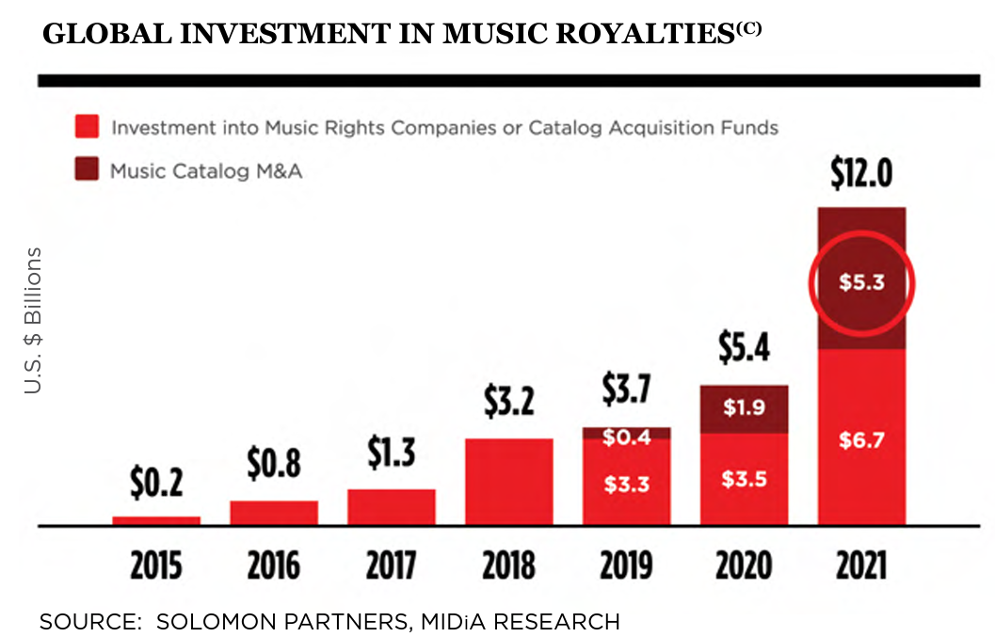

Pension funds, endowments, and other entities seeking safe and consistent returns have been known to invest in music catalogues or music royalty generating businesses for some time ⇒

**music publishing assets**: from buyers paying an average of 8.3x the net publisher share to 20.6x by 2019, an increase in average multiples paid of 248% (*NPS = gross revenue less writer royalties and administration costs*)

**recorded music:** multiples paid for recorded music catalogues also doubling from an average of 6x the net label share in 2012 to 12.7x by 2019, an increase of 211% (*NLS = revenue less royalties and marketing and distribution costs*)

NPS: Net Publisher's Share means the licence fees, royalties and other revenue received by a Person from the exploitation of its musical compositions less all licence fees, payments, royalties and other amounts

NLS: Net Label’s Share revenue received by a Person in connection with the exploitation of its musical recordings less payments, royalties and other amounts paid

A good portion of multiple growth has been driven by streaming, but also demand and production of visual content (accompanied by music)

Private and public funds have spent an estimated $5 billion acquiring music royalty rights in 2021 alone

Streaming growth is expected to remain strong despite predicted recessions

**Goldman Sachs 2030 estimate**: 38 billion live music, 80 billion recorded, 12.5 billion publishing, total of 130.5 billion by 2030

Goldman also increased its streaming revenues forecast based on ARPU (average revenue per user) from $42.80 to $45.80 by 2030,

163$ on av of yearly budget in the 18-34 year old category goes towards streaming music, 152$ for all ages

**Streaming Earnings Compared to Other Music Formats**

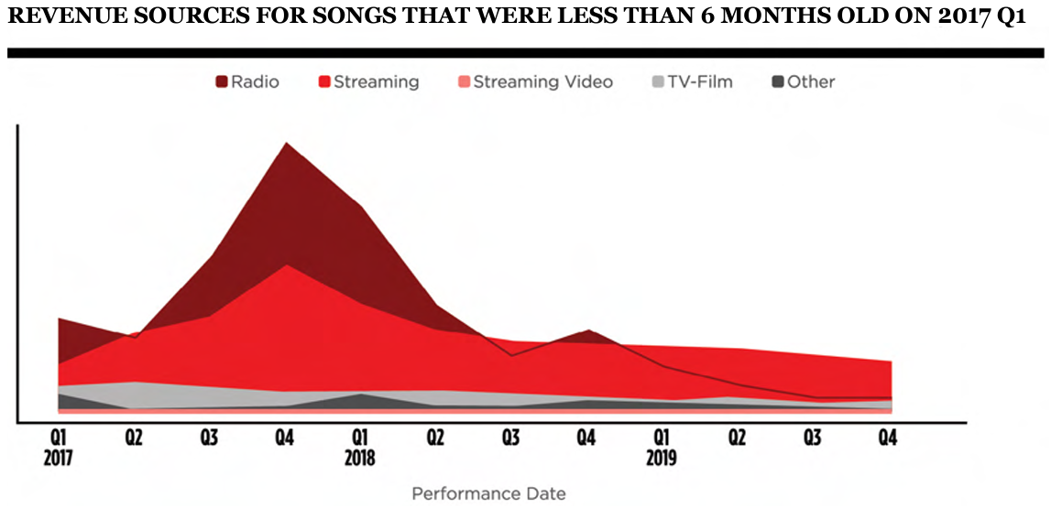

This data reflects earnings from performing rights organisations ASCAP and BMI for thousands of songs no older than six months old in Q1 2017 submitted to the online royalty marketplace Royalty Exchange for analysis

**Streaming and the Value of Music Copyright**

Streaming will continue to have an outsized contribution to music industry revenues despite concerns that subscriber growth will slow

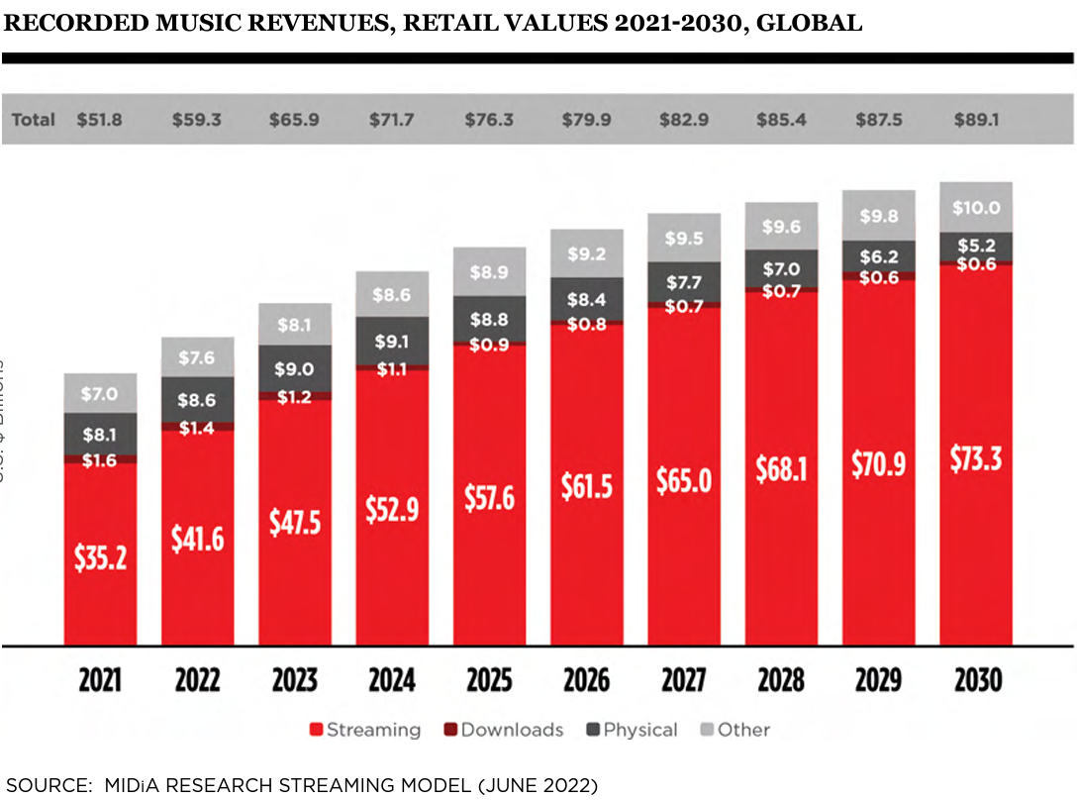

**Decay Curves**

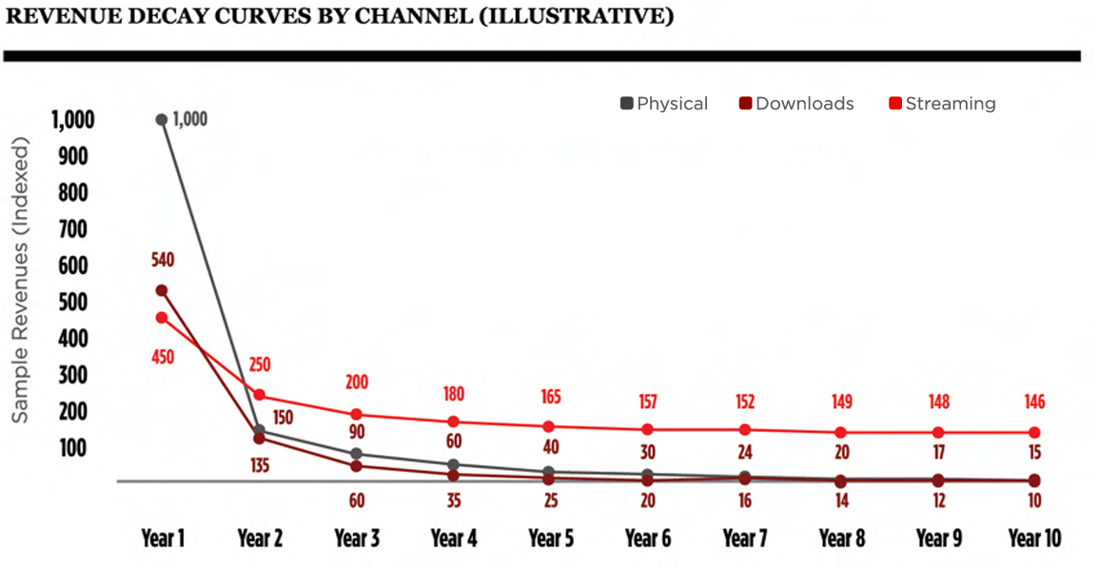

Investors value predictability and data transparency ⇒ offered by music streaming

The yields music royalties generate are insulated from the vagaries of public markets or political risk ⇒ royalty rates due for music licensing do not change since rates are negotiated for multi year terms

Factors of music royalties that mitigate stock market like risk:

* Royalties paid based on use ⇒ puts owners of royalties closer to the revenue
* Copyright law protects royalty assets for a long time compared to alternatives ⇒ 70 years typically
* Royalty earnings are relatively stable, consistent, and persistent over time
* Many catalogue acquisitions happen five to seven years after initial release ⇒ revenues become predictable

**Streaming Impacts Catalogue Consumption**

Catalogue music (defined as music older than 18 months) comprised fully 69.8% of music consumption in 2021 (Luminate, 2022)

Catalogue accounted for 70.2% of consumption in the US in 2021 due to Streaming

⇒ age of those streaming the catalogue is getting younger

⇒ streaming is causing recent hits to stay popular for longer

**Estimate of Streaming’s Contribution to Catalog Value**

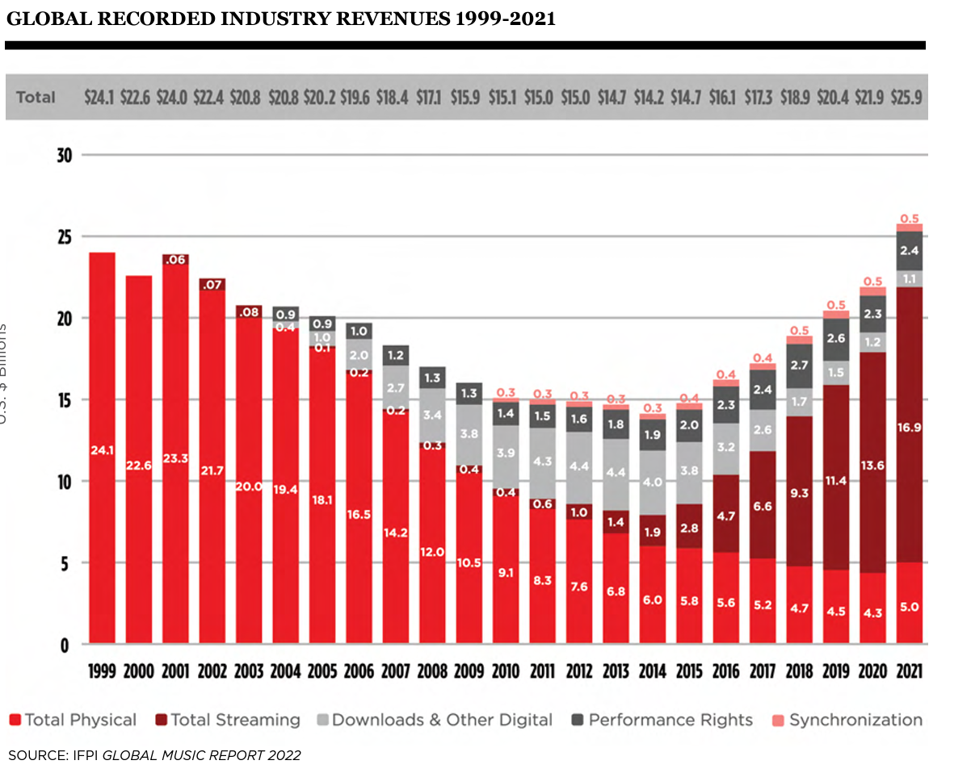

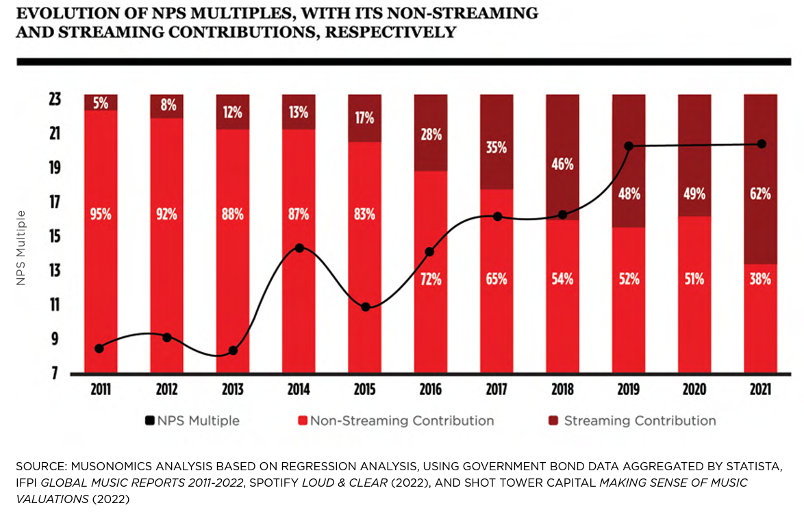

FULL ANALYSIS OF **CORR(**STREAMING, CATALOG VALUE**)**

## Merchandise Statistics

### Spotify for Artists: “Your Music and Merch Are Better Together”

Spotify data shows that a lot of merch engagement also comes from new fans who just discovered you

New fans are 7.8x more likely to click on your merch the very first day they discover you, compared to just one day later

### Spotify for Artists: “Catalog” and “Merch + Music”

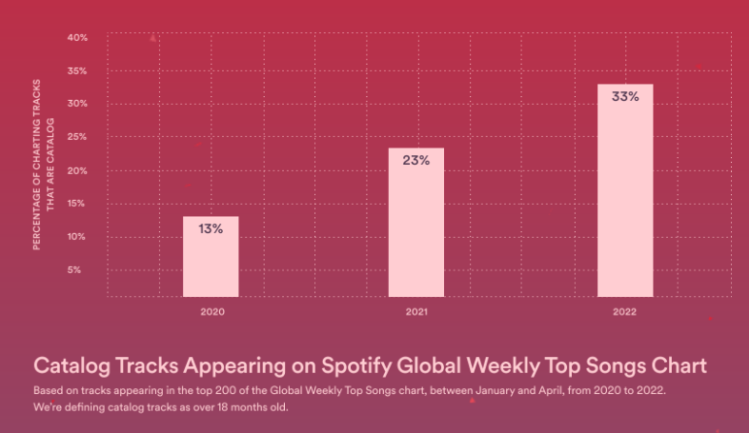

Increase of 155% since 2020

Of fans that bought merch on Spotify in 2022, 88% **streamed catalogue** of the artist they purchased from, compared to only 67% that **streamed frontline** tracks

If you play it right, one track's viral moment can lead to long-term fans. After artists have their first song go viral, we see a 70% increase in streams for the rest of their music (excluding the viral song)

For listeners under 25, over the past four years, their portion of total streams represented by music from the 80s has increased by 45%

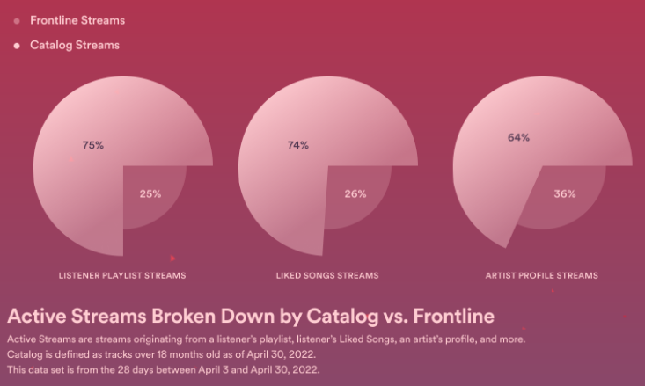

In the days and weeks after you drop a new release, fans flock to your artist profile. More than half of all merch clicks come in the first 24 days after a new release

Two thirds of all your merch clicks come from fans who follow you, like your songs, or add them to a playlist.

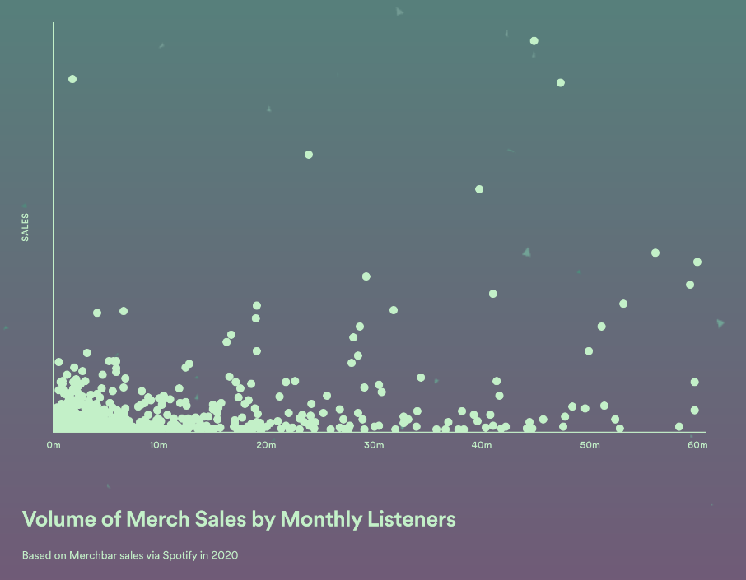

### atVenu: “A Year In Review 2022: The Merch Edition”

$8.16 Avg. Dollar Per Head

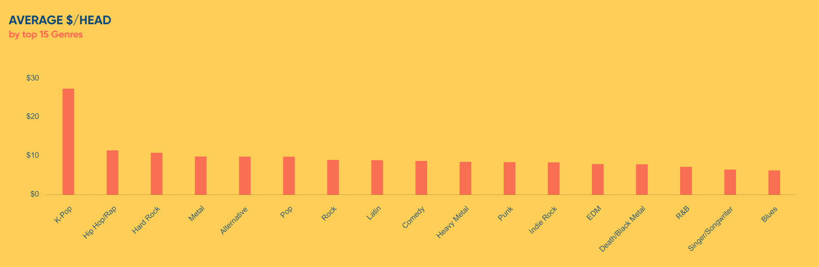

avg. $/Head top 5 genres:

K-Pop: $27.25

Hip Hop/Rap: $11.34

Hard Rock: $10.73

Metal: $9.76

Alternative: $9.74

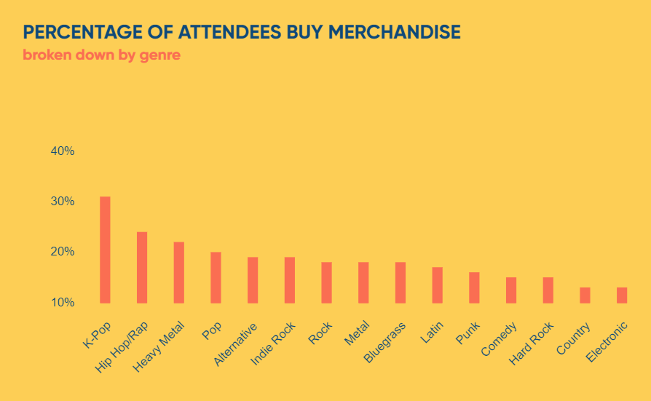

## NFT Sentiment Analysis

### “NFTs in Music: Exploring the New Frontier of Fan Engagement and Revenue Streams”

Role of NFTs:

* Preventing copyright infringement
* Proving ownership
* Giving power back to artists
  + Can have full or fractional ownership of their music
* Cutting out intermediaries
  + Allows musicians to deal directly with their fans

Uses of NFTs:

* Music NFTs
* NFT Ticketing
  + Tickets for live events
* Unique Digital Collectibles
* Access to Exclusive Experiences
* New Revenue Streams
  + Grant artists percentage of their royalties

### Galaxy: “NFT Marketplace Update” (May 2023)

Royalty fee paying transaction in decline in all NFT marketplaces ⇒ From OpenSea and Blur’s YTD highs, down 90%

OpenSea’s decision to enforce 0.5% for royalties instead of their typical 5.0%-7.5% is the key factor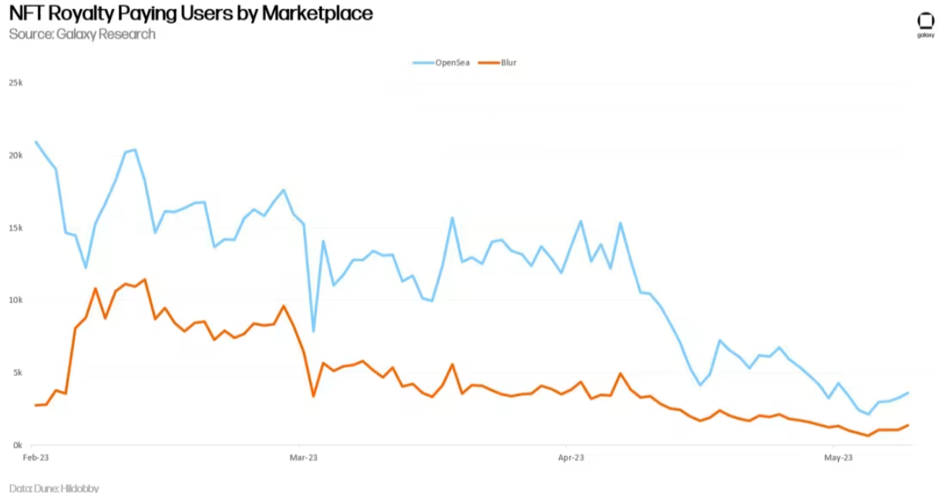

### Galaxy: “NFT Royalties: The $1.8bn Question”

Over $1.8bn worth of royalties have been paid out to creators of Ethereum-based NFT collections

The only way an NFT royalty could be programmed into a smart contract is if the program somehow knew precisely when an owner is transferring an asset between his/her own wallet or selling an NFT to a buyer

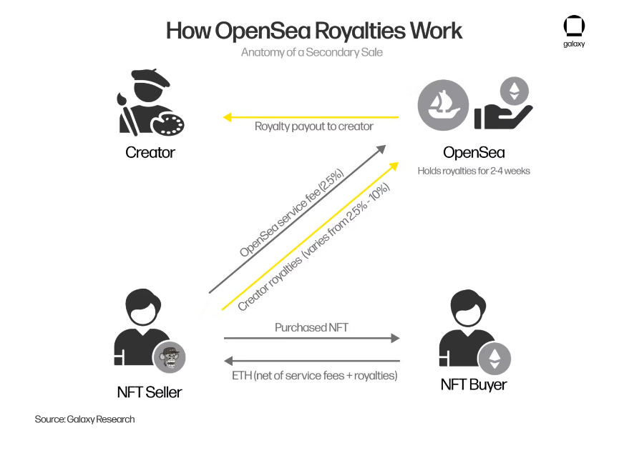

### Water & Music: “New pathways: Analysing music NFT release strategies from underrepresented genres”

74% of music NFT sales in 2021 were in either Electronic or Hip-Hop genres

### Water & Music: “Analysing fan sentiment of music NFT drops” (2021)

Mixed reactions to NFTs, some artists that did drops had to distance themselves from them due to backlash: Charli XCX, Interpol, Crazy Frog, Method Man and A$AP Rocky

⇒ article names environmental worries as the lead driver to the backlash

⇒ article names financial costs as top mentioned concerns alongside env

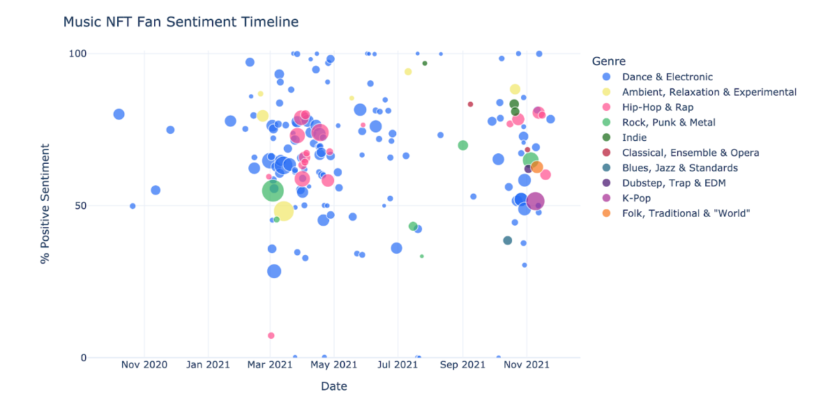

75% of the list is electronic

Size of dot is overall engagement on Twitter

Music NFT sales dropped 90% in Q2 compared to Q1 due to ‘crypto winter’

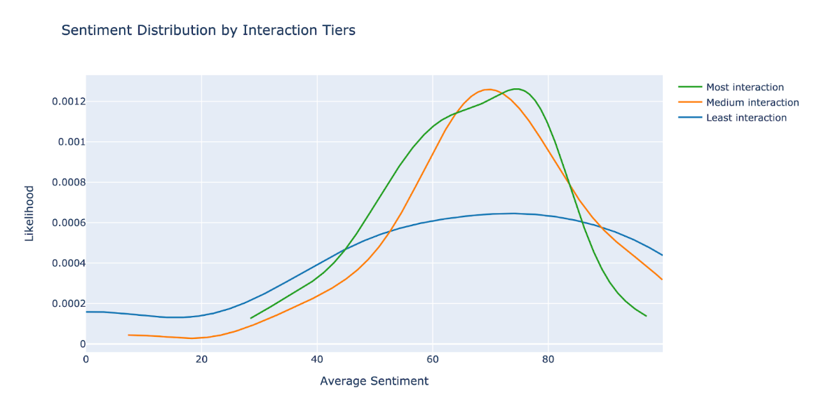

Cannot say with confidence that smaller artists’ NFT drops are better received

## 

## Competitors

### Global Rockstar

Immutable and traceable smart contracts ⇒ secure the purchased rights as smart contracts in the blockchain

Additionally, many music assets on the platform let you participate as well in revenues from radio plays, TV, synchronisation rights, live and CD sales

Global Rockstar is a music label, a music publisher, and an online platform ⇒ you can invest into their artists and they will provide the money as the music publishing company

Our Artist & Repertoire department has more than 25 years of experience as successful music producers and label managers

“By utilising computer code and blockchain technology, smart contracts enable secure and transparent transactions without the requirement of a central authority, legal system, or external enforcement mechanism.”

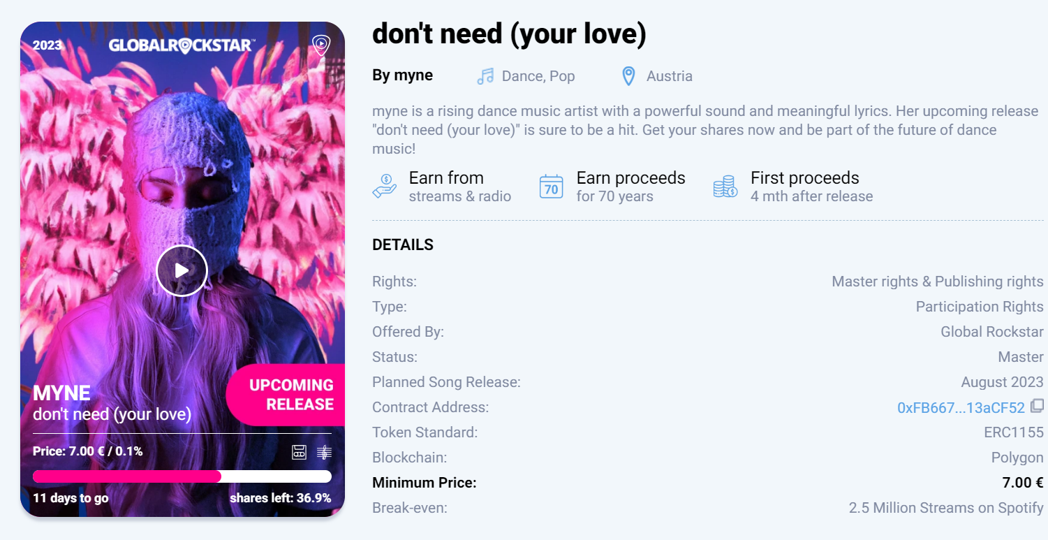

They calculate the breakeven point of the song and offered royalties

Global Rockstar is a label, so they offer royalties for their artists

### Royal.io

Justin Blau (3LAU) founder of royal in may 2021

Diplo, Nas and Chainsmokers as part of their offering ⇒ large artists

Caterpillar ft. Eminem

**Very clean interface**

$7.5M IN MUSIC RIGHTS TRADED /// $195K EARNED BY COLLECTORS /// $2.6M RAISED FOR ARTISTS

The company is backed by musicians such as The Chainsmokers, Logic, and Kygo

Song rights are divided into three different tiers with separate rewards and ownership percentages ⇒ using tokens as if it were NFTs, no fractionality

### ANote Music

Founded in 2018

“Join the fastest growing music investment platform, allowing investors and music fans to earn royalties together with their favourite record labels, publishers and artists.”

MATHEW KNOWLES, FATHER OF BEYONCÉ AND SOLANGE, JOINS ADVISORY BOARD AT ROYALTY MARKETPLACE ANOTE MUSIC (2021)

**They have catalogues from artists and music labels**

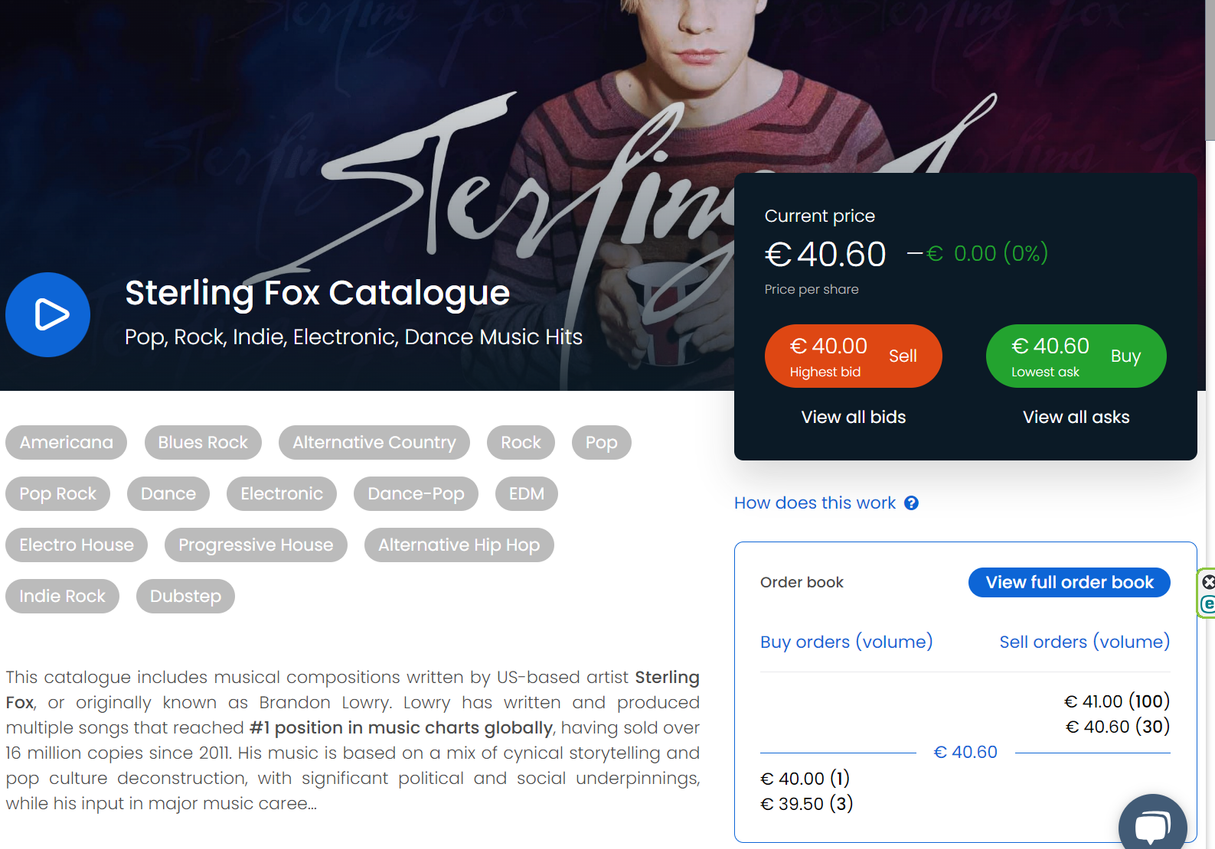

In October 2020, there were more than 3,000 registered accounts on the chapter and 350,000 euro had been committed by investors. 12,000 euro was paid to investors in the first three months after launch.

### Royalty Exchange

American company that operates an online platform for buying and selling royalty assets of any type, mostly music

$140million raised by rights holders and 1750+ deals completed

30,000 registered investors

Founded in 2011, it has subsidiary Royalty Flow

**Royalty Flow**

Royalty Flow seeks to raise at least $11 million through the IPO, but will accept up to the $50 million limit

Royalty Flow provides investors direct access to not only the growing music business, but to only the most premium, cherry picked catalogues within the music industry

Royalty Flow is a specialty financing company created to acquire passive interests in premium, royalty generating catalogues

Shareholders in Royalty Flow are eligible to receive dividends based on the performance of the royalty assets it holds, and participate directly in the growth of the music and media industries

### SongVest

Founded in 2007,

Registered users can bid on the opportunities when they go live. SongVest then provides closing paperwork and notifies the organisations that pay the royalties of the auction results.

⇒ bidding system

SongVest auctions as of summer 2021 included the writer's share of hits by Flo Rida and catalogues that include songs recorded by Cardi B, Notorious B.I.G, Travis Scott, Busta Rhymes, Mariah Carey, Onyx, and Sister Hazel.

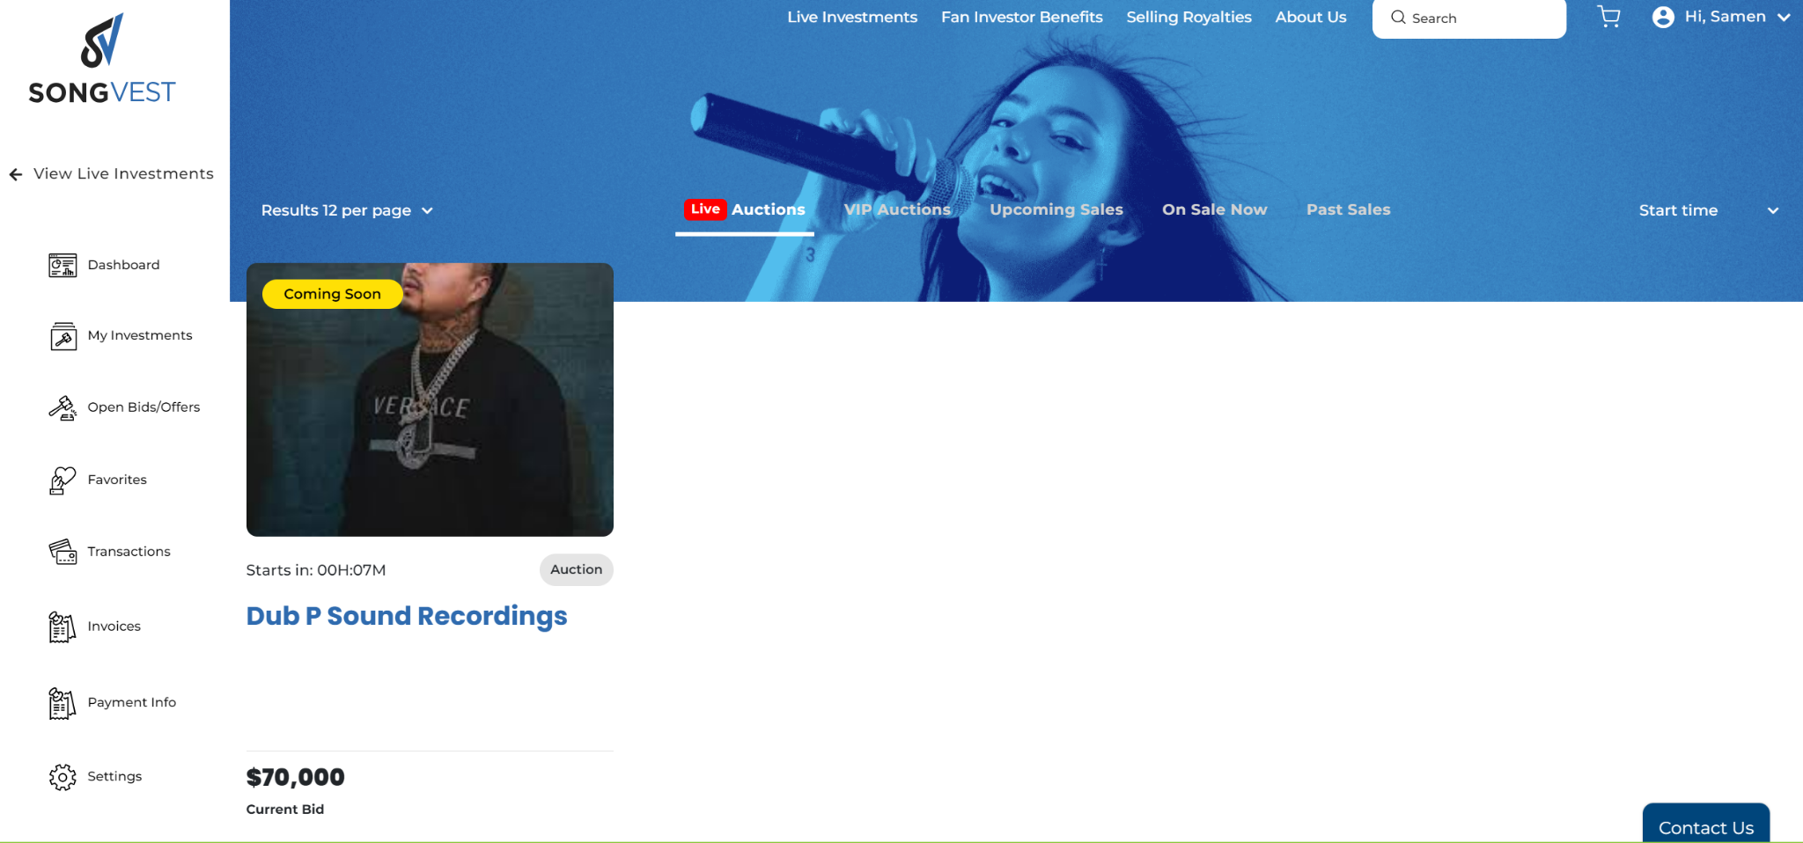

### Master Exchange

| **Name** | **Comparative Adv** | **Comparative Disadv** |
| --- | --- | --- |
| Global  Rockstar | Music label ⇒ has artists signed up  Uses blockchain and secure transactions  Low minimum share price for some artists  More than 25 years of experience  Selling both master and publishing rights | Limited artist choice  No catalogue or album deals  No fractional shares |
| Royal | Our most prominent competitor  Very nice user interface  Some big names backing the project  Very impressive volume traded  Their three tier tokens act almost as fractional shares | No catalogue or album deals  Nas, for instance, has one song posted on the platform |
| ANote  Music | Team of well experienced executives  They have catalogue deals from artists and other labels | No fractional shares  Fast initial growth but slowed down  Limited artist choice |
| Royalty Exchange | Use a comparable market analysis to value their royalties | Bidding system |
| SongVest |  | Bidding system |
| Master Exchange |  |  |
| Bolero |  |  |

## Trading Standards

### Finder: “Trading Fee Statistics”

Out of the 13 trading platforms analysed, 5 platforms will charge over £1 in trading fees for a £50 trade: Hargreaves Lansdown (£12.45), AJ Bell (£10.33), IG (£10.25), Interactive Investor (£8.74) and Fineco (£4.45). There are 8 platforms where trading fees will be less than £1 for the £50 trade: Degiro (£0.05), Trading 212 (£0.08), Freetrade (£0.23), eToro (£0.25), Stake (£0.25), Revolut (£0.50), Lloyds (£0.50) and Halifax (£0.63).

Source: <https://www.finder.com/uk/trading-fees-statistics>

Analysis conducted by finder.com

## Record Labels

### [Rolling Stone](https://www.rollingstone.com/culture-council/articles/what-is-the-role-of-record-label-in-todays-music-business-1234588863/)

* developing, distributing and marketing music have all become tasks that no longer always require a huge team or an interconnected network
* Instead, the right manager can oversee the business operations, outsource production and negotiate distribution
* Some of today’s best labels are more niche precisely because this allows them to provide tailored resources to every artist under the label

### [What is a Record Label?](https://exploration.io/what-is-a-record-label/#:~:text=Record%20labels%20are%20companies%2C%20large,and%20the%20products%20they%20create.)

Record labels began emerging in the late 1800s when phonographs and phonorecords began to commercialise as technology allowed mass production

major labels, major label subsidiaries, and independent labels (see our Major vs. Indie guide, [here](https://exploration.io/major-vs-indie/)). Today, the record companies considered to be major labels are referred to as the “big three.” In 2016, the big three possessed nearly 70% of the world market share of recorded music: Universal Music Group (28.9%), Sony Music Entertainment (22.4%), and Warner Music Group (28.9%).

### [Role of Record Label](https://www.stereofox.com/articles/the-core-functions-of-a-record-label-in-2022/#)

## Artwork, Creative Vision and Music Videos

Visuals is an integral part of branding, with that being said you’d be hard press to find a label without a design team or designated designer. For the artist, handing over this responsibility to the label allows them to particularly focus on the creation of music